Mteshane, Abongile

Fundraising platform system research

Contents Page
Abstract 2
Introduction 2
The ideal process in summary: 2
Literature review 3
Existing systems 3
Examples of application systems: 3
USE CASES 0
Methodology / Research Design 0

Abstract
This paper is based off research for a centralised fundraising system, that handles the fundraising processes automatically. Human interaction will still be part of the process, given that not everything can be handled by the system, but based off my understanding, this should be a system in which will be used throughout the university to handle fundraising for projects, faculties, departments etc.
The problem is that departments within the university will go look for funding outside of the development and fundraising office knowing. The solution of this system is to track, update and handle donor data.

Introduction
This system will be targeting the university fundraising system. The problem statement is that “there is no centralised platform for the fundraising process”. The purpose of this research is to see if there are organisations, or if there is software that can be implemented to create the system. To find the different ways in which this system can be done and built.
The hypothesis:” How can a comprehensive fundraising system be designed to manage the entire lifecycle of university fundraising, from donor prospecting to post-donation stewardship within a single, enforceable digital environment?”

The ideal process in summary:
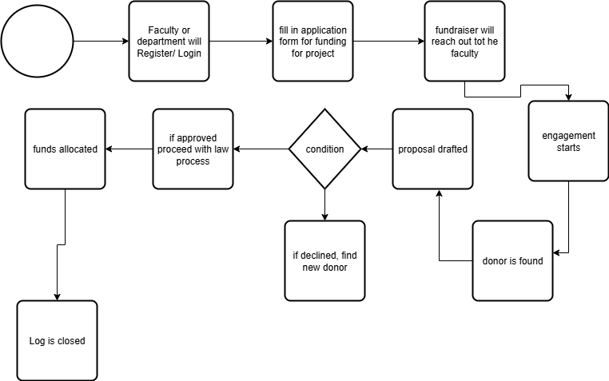

Literature review

Existing systems
There are some existing platforms on the internet. From my understanding, this system can work as an application system or a booking system. For example: The National Traffic Information System s the centralised system for booking a drivers license test in most provinces.
I compare it to a booking system because faculties and departments need to “apply/ book” for funding given that they need to be associated with a fundraiser which deals with that particular faculty. That will handle the introductory stage of fundraising

Examples of application systems:
- NSFAS application system
- Home affairs booking system
After the introductory stage we have the engagement stage. Where now a fundraiser will engage more with the faculty. Getting to know more of what they need for the project or event. That process can be done outside of the system because I feel like it would be nonessential to have; to have fundraisers log every interaction they had with the applicant party.
Once the fundraiser and applicant party have spoken and are sure on what is needed. They will have to decide on weather a proposal is needed or not. Weather the faculty already drafted a proposal, or they will need to be helped with drafting one. The system can have some templates ready or have a way for the faculty to fill in some keywords then the system will create the proposal for them.
While the proposal writing is happening, the fundraiser is looking for a potential sponsor. In those interactions that the fundraiser, the applicant party states the information, which then the fundraiser will look at which company is best suitable for the faculty or event.
If the proposal gets approved by the sponsor, the legal process starts. The drafting of contracts, being taken to legal etc.
Once contract is approved, funding is allocated to the department or project and then that’s when the “Log” is closed. And the process is complete

USE CASES

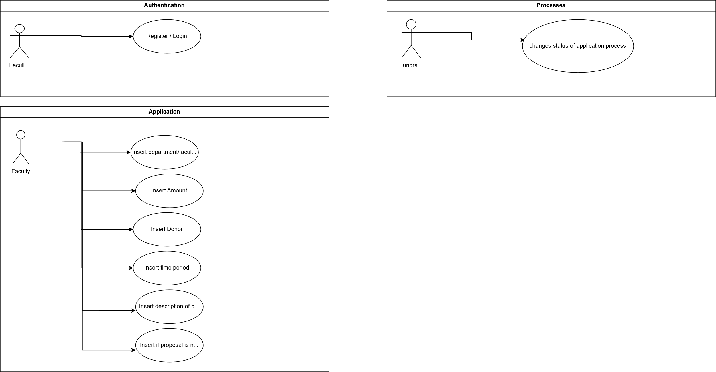

Entity relationship model
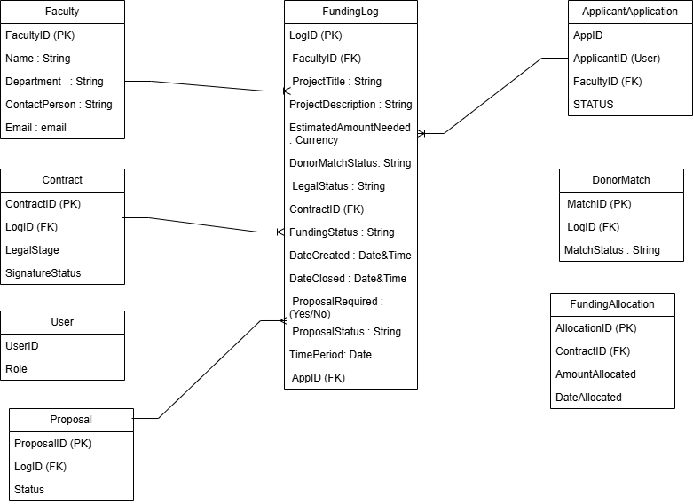

Methodology / Research Design
Model that will be used is the AGILE Model, as the agile model has room for flexibility and adaptability to change
